**Page 1: Maybe something like this for a brief background? I am sure there are gaps…**

This shiny application provides a simple user interface that provides various options for delivering the Philadelphia Naming Test (PNT; Roach et al., 1996) in an item response theory framework (IRT). The PNT is a confrontation naming test utilized for assessing anomia severity from people with aphasia. The IRT parameters of this model were estimated with an archival picture naming tests set of people with aphasia (Mirman et al., 2010). Please note, that the intended population for this assessment are individuals with acquired language impairments and the testing instrument may be unreliable for other populations.

This application provides clinicians the ability to assign the number of items to be delivered to a participant. Options for the number of items include 30, 175, and a variable length version. All tests deliver items per a computer adaptive testing algorithm (CAT) that which is described in detail below. Picture naming severity, as measured by the number of items responded to correctly, on the 30 item PNT CAT (PNT-CAT30) correlate highly (r = 0.95) with the number of incorrect responses on the full PNT (Fergadiotis et al., 2019). The variable length PNT-CAT (PNT-CATVL) was designed to be administered after the PNT-CAT30 to assess change in anomia. Importantly, he PNT-CATVL does not administer any overlapping items with the PNT-CAT30. Instead, the items delivered to the participant are chosen based on the participants previous naming ability estimate. The item selection algorithm for the PNT-CATVL stops administering items when the modeled precision of the ability is greater than or equal to the value obtained by the PNT-CAT30. Estimates of anomia severity estimated between the PNT-CAT30 and the PNT-CATVL correlate highly (r = 0.89)

Upon completion of the PNT-CAT30, PNT-CATVL, or the full PNT the application provides a naming ability and its standard error of measurement for the participant and an option to save this information desktop. Participant information is not saved by the application. If you wish to utilize the PNT-CATVL to assess change in naming severity, you must have a saved and unmodified, version of the output to provide the application prior to administering the PNT-CATVL.

Anomia, or word finding difficulties, is invariably present in people with aphasia. Picture naming tests can be utilized to provide valuable information on how words are accessed and retrieved. Such tests can be found as parts of neuropsychological assessments (Goodglass et al., 2001; Howard et al., 2010; Kertesz, 2006) and standalone testing instruments (Kaplan et al., 2001; Roach et al., 1996). The Philadelphia Naming Test (PNT; Roach et al., 1996) is a 175 item picture naming test utilized to assess anomia in people with aphasia. It is made up of diverse stimuli varying in length, age of acquisition, and lexical frequency (Francis & Kucera, 1982), it has a well-defined scoring system for classifying anomic errors (Dell et al., 1997), and its total score correlates highly with aphasia severity (Walker & Schwartz, 2012). Outcome data from the PNT and be utilized to make inference on overall naming impairments and breakdowns in lexical-semantic and lexical-phonological processing.

Despite the strengths of the PNT, it comes with two notable limitations. First, it was developed in a The PNT was developed in a classical test theory framework (Traub, 1997). Second, the length of the assessment may make its use challenging in fast paced clinical contexts. Regarding the former limitation, within the CTT framework, standard error is considered constant across all items regardless of the items difficulty or the participants naming ability. This assumption ignores that measurement error varies as a function of item difficulty and naming ability. To illustrate this point, consider the following example. If a test were administered to a group of people with very mild anomia that only included very easy items they would all likely score perfectly. Therefore, rank ordering these participants based on their naming ability would not be possible. However, if a test of more difficult items were delivered to the same group of people with aphasia, it is less likely they would all perform perfectly and rank ordering the individuals would be possible.

Item Response Theory (IRT; De Ayala, 2009; Lord, 1980) is a modern psychometric theory that formalizes the probability of a correct response given an items difficulty and the participants ability. Difficulty can be conceptualized as the ease or challenge of producing a correct response and ability is operationalized as the degree to which an individual possesses a certain skill. Recently, a1-Parameter logistic (1-PL) model (a utility of IRT) was fit to the 175 items of the PNT with archival data (Mirman et al., 2010) from 251 participants with aphasia (Fergadiotis Gerasimos et al., 2015). The 1-PL model is expressed as follows:

$$P\left(x_{i}=1 | θ_{j}\right)=\frac{e^{α(θ_{j}-β_{i})}}{1+ e^{α(θ_{j}-β_{i})}}$$

Where the probability of (P) of a correct response by examine *j* with a naming ability $θ$ is equal to a log transformation of the participants naming ability minus the item’s difficulty $β$. Note that $α$ is the item discrimination parameter, which is assumed to be equal for all items under the assumptions of the 1-pl model.

Item characteristic curves can then be estimated for each item for all possible ability levels. Item characteristic curves are sigmoidal in shape and are presented for the following items in Figure 1: Ambulance, ball, and microscope. Note that zero is considered the population level naming ability estimate and average item difficulty. As can be extracted from the figure, a participant with a naming ability has a probability of responding correctly to ambulance, ball, and microscope of roughly 0.33, 0.80, and 0.15, respectively.

Figure 1: Item Characteristic Curves

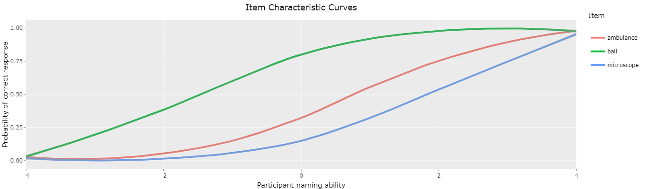

The amount of information that each item carries about a given naming ability is formalized by the item information function. Information is formalized as:

$$I_{i}=P_{i}(θ) Q_{i}(θ)$$

where the information for item *i* is the product of the probability of a correct response for an individual with an ability of $θ$ multiplied by the probability of an incorrect response for item *i* from an individual with an ability of $θ$. For an interactive application that can be utilized to plot item characteristic curves for any item on the PNT see <https://aswiderski.shinyapps.io/IRTapp/> and for ease of visualization Figure 2 provides item information curves for the items “ball” and “stethoscope.” Figure 2a demonstrates how more information is acquired when the word “ball” is administered to an individual with more severe aphasia in comparison to a more difficult item such as “stethoscope.” In contrast, Figure 2b demonstrates that the item X and X provide nearly identical amounts of information while figure 2C shows that items X and X are only slightly easier and harder than item X, respectively.

The ability to quantify how much information may be acquired by administering a given item to a individual is central to our recent efforts in developing computer adaptive tests (CAT) utilizing the PNT as an item bank.

short form PNTs that i) correlate highly with the full PNT and ii) may be administered to people with aphasia with nonoverlapping items with an overall estimate of anomia severity that correlates highly to the original estimate.

Figure 2: Item information curves

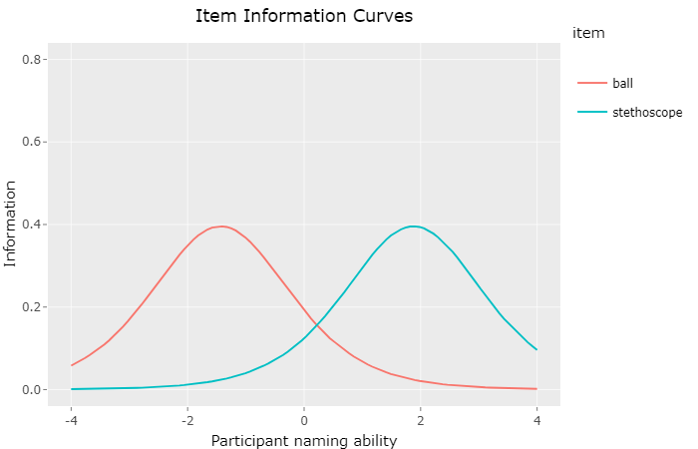

**Next sections:**

* **Computer adaptive testing**
* **PNT-CAT30**
* **PNT-CATVL**
* **Should we include a FAQ page?**
* **Screenshots?**